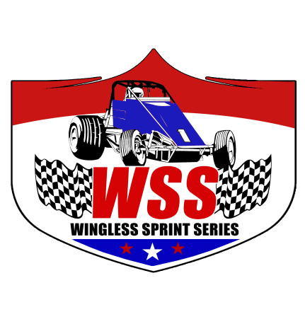
2022 Membership Application
Driver Name: _______________________________________
CAR #: _________
Membership Fee: $100
Payable to:
Wingless Sprint Series
16640 SW Baywood Ct.
Sherwood, OR 97140

(Due by 1st Race)
Address: _______________________________________
City/State/Zip: _______________________________________
Home Phone: _______________________________________
Work/Cell: _______________________________________
Email Address: _______________________________________
Emergency Contact: _______________________________________
Emergency Phone: _______________________________________

Are you eligible for Rookie of the Year? Yes No
(To be eligible for the 2022 Rookie of the year, you must run a minimum of 4 races. If you have competed in 4 or more past WSS/NWWT/ODSS events, you are not eligible for Rookie of the Year).

I hereby agree that I will abide by all the rules and regulations set forth by the race tracks and the Wingless Sprint Series including, but not limited to the following:

- I have or will have familiarized myself with all the Wingless Sprint Series rules and regulations, including car specifications and safety rules and I agree to abide by all such rules and regulations.
- I agree and understand that by submitting/entering my race car for an event, that my race car meets all the rules and regulations for participation in Wingless Sprint Series events, and I understand the burden of proof will rest upon me to show that I am in compliance with all said rules and regulations, and I understand that violation of said rules can result in fine, suspension and loss of all series points.
- I agree that all decisions of track officials will be final. I further agree that I will not initiate any type of legal action against race track and/or Wingless Sprint Series officials, nor will I seek monetary damages, injunctive relief or any other kind of legal remedy. I understand that if I pursue any such legal action, which violates this provision, then I expressly agree to reimburse the speedway and/or the Wingless Sprint Series for all of its attorney fees and cost in defending against such legal action.
- I further understand that there is no express or implied warranty of safety resulting from publications or compliance with the Wingless Sprint Series general or car specifications and safety rules and that they are intended as a guide for the conduct of the sport and are in no way a guarantee against injury or death to participants, spectators or others.
CERTIFICATION

I HAVE READ AND WILL FOLLOW ALL TRACK AND WINGLESS SPRINT SERIES
RULES AND REGULATIONS. ___________ (INITIAL)

Signature: _____________________________________________ Date: __________________

Received By: _______________________________ Date ______________

